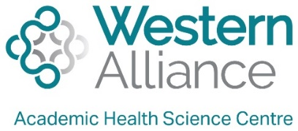
STaRR: Supporting Translation of Research in Rural and Regional Settings

Expression of interest: Research translation workshops for health managers and leaders

Western Alliance’s STaRR initiative includes a Health Practitioner Research Translation Training program that supports building research translation capability in rural and regional health settings. This mentored training program, focussed on research translation in rural and regional health settings, includes training for research mentors, emerging researchers and health managers/leaders.
Recognising that managers and leaders are integral to supporting practitioner-led research and effecting change through the translation of research and knowledge, Western Alliance is now offering research translation workshops for health managers and leaders (both clinical and non-clinical) as part of our STaRR initiative. The aim of these workshops is to gain a common understanding of research translation, including the process and potential impact. Health managers and leaders are invited to submit this EOI to info@westernalliance.org.au by 16th March 2021. Note that all costs associated with this online training are covered by Western Alliance.
STaRR is a multi-dimensional research capacity and capability building approach that includes:
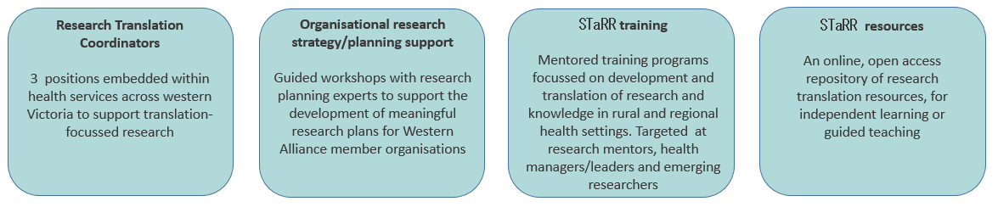
For more information contact Drew Aras E: drewaras@westernalliance.org.au; M: 0402777385 or Olivia King E: Olivia.king@barwonhealth.org.au

Why manager and leader workshops?
Manager and leader support is integral to practitioner-led research and research translation.
Managers and leaders can:
- Provide strategic direction
- Provide material support (e.g. funding, resources, backfill for clinic time) for research active practitioners
- Provide in-kind support (e.g., allowing practitioner time to be allocated to research and translation)
- Identify and link practitioners in with relevant people and resources
- Promote and disseminate practitioners’ research work and their findings to others within the organisation including senior managers and executives
Understanding managers’ expectations of research translation is critical to research capacity building and sustainable research translation outcomes. These workshops will provide education on a common research translation framework to guide discussions regarding training, implementation and impact.
Who can participate?
Managers (any level) and leaders (e.g. senior clinicians) working within health service or primary care settings at a Western Alliance partner

organisation*. Note that no prior research experience is not necessary.
Workshops overview
The workshops will comprise two x 2.5-hour online sessions that will cover the following broad topics:
- General introduction to research
- Regional research landscape
- Ethics and governance
- Research translation
- Collaboration between health organisations and universities
- Process to determine which research projects and ideas to support
- Research dissemination
These topics will be covered with respect to the roles of managers and leaders.
Proposed timeline
EOI open (managers & leaders) | 25th February 2021
EOI close (managers & leaders) | Extended to16th March 2021 (5pm)
Managers research and research translation workshops | 1 - End of April  2 - Mid May

STaRR: Supporting Translation of Research in Rural and Regional Settings

Expression of interest: health manager research translation workshops

Please complete the following questions (maximum 150 words per response)

- Do you currently have practitioners in your team conducting research or translation activities?

Enter text

- Are you currently engaged in research or translation activities? (note that prior research experience is not required for to be eligible for this training)

Enter text

- What are your research interests (if any)?

Enter text

Name: Enter text
Employing organisation: Enter text
Current role: Enter text
Email address: Enter text
Phone number: Enter text
By signing below, you indicate that you have gained support from your line manager/head of department to participate in this initiative:

Signature………………………………………………………..

Please submit completed EOI to: info@westernalliance.org.au by 5pm, 16th March 2021.

