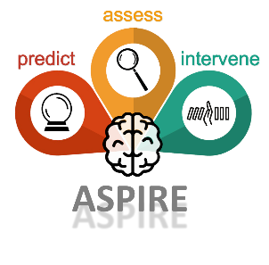
Advertisement PhD student PhD program Barwon Health-Deakin University

The Opportunity
In Australia, physical violence (domestic violence, random assault) is the third common cause of traumatic brain injury (TBI). These estimates likely underestimate the actual numbers, because many instances of assaults or mild TBIs go unreported. The COVID-19 pandemic has exacerbated the incidence rate of assault. This proposed research project will cover three broad aims, following a paradigm of ‘ASsess-Predict-InteRvEne’ (ASPIRE): (i) ASsess: Characterise the trajectories of mental health functioning in subgroups of assault TBI survivors using multimodal data; (ii) Predict: Ascertain which pre-injury, injury-related and recovery-related variables best predict the onset, severity and development of mental health deficits; and (iii) InteRvEne: Identification of single-subject profiles that facilitate development of individually tailored training programs that improve mental health functioning in assault TBI patients.
The Role
We have a PhD stipend for the right student to undertake a longitudinal study that will recruit individuals in the early aftermath of assault from the Emergency Department of Barwon Health. The PhD student will administer a state-of-the art multilayer array of measures, including Biospecimen, Neuroimaging, Ecological Momentary Assessment, Self-report and Clinical variables. This information will guide the development of novel personalized care and prediction models to improve the mental health functioning of assault TBI survivors.
The PhD candidate will be supported by a well-integrated, multidisciplinary supervisory team with a mix of academic and clinical backgrounds. The PhD stipend is provided jointly by Deakin University and Barwon Health, with the successful applicant enrolled via Deakin University. Project funding of $10,000 is also provided in the first year by the Barwon Health Foundation, with opportunity to apply for further project funding in years 2 and 3.
How to Apply
Interested persons must:
• contact Prof Karen Caeyenberghs at k.caeyenberghs@deakin.edu.au prior to 27th August 2021 to discuss the PhD stipend on offer,
• submit their CV and covering letter to k.caeyenberghs@deakin.edu.au prior to 1st October 2021 addressing the following selection criteria:
- must have an Hons degree (H1) or equivalence in a related discipline (see
https://www.deakin.edu.au/research/research-degrees-and-PhD/research-degree-entrypathways for further information on minimum entry requirements)
- a genuine interest in cognitive neuroscience and psychology
- be enthusiastic to work with TBI patients within the hospital setting on a multidisciplinary project
- demonstrated experience in one or more fields including: cognitive neuroscience, psychology, neuropsychology, or similar.
- self-management and high personal motivation
- high level of organisational skills
- excellent communication and interpersonal skills
- be located within Australia

