JULY 2022 |  | Barwon Health Social Supports Program McMillan St, Anglesea  Phone: 4215 6721
MONDAY | WEDNESDAY |  | FRIDAY
1 The Drive in

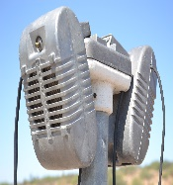 Reminiscence
4  Independence Day  American theme | 6  Bingo & Hoy |  | 8  Golden Rules days  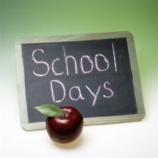
11  Games afternoon –  your choice | 13  Bastille Day  French theme |  | 15  Whiteboard words
18  Scrabble | 20  Lunch outing to Anglesea Golf Club  Please bring $25 cash  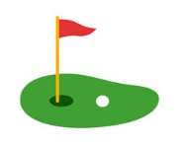 |  | 22  The Price is Right: Come on Down !!
25  Active games | 27  QI Gong with Judy |  | 29  Family Flip quiz

