MARCH 2023 | Barwon Health Social Support Program  230 Purnell Rd Corio
 | All cancellations to be made by 9:00am on day of attendence: 0447 515 507 or 4215 7049
Monday | Tuesday | Wednesday
 |  | 1st
 |  | Morning walk around the Geelong Yacht Club
6th | 7th | 8th
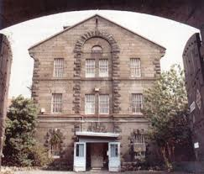  Geelong Gaol Museum guided tour $15  Late lunch | Morning tea at The Aviary Café $  Short drive  Late lunch  Card games, Rummy-o, jigsaw puzzle | Morning trip to Op Shop or Cheap As Chips.  Brain gym  Afternoon trivia, funny guessing games or whiteboard games
13th | 14th | 15th
PUBLIC HOLIDAY  NO PROGRAM | 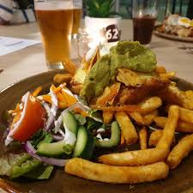  Morning chat and games  Lunch at Fyansford Hotel $20 | Are the bats still at Eastern Gardens? Let’s wonder along the coast or the Botanical Gardens.  Late lunch  Afternoon activity of choice
20th | 21st | 22nd
Morning discussion group. What will the topic be today?  Lunch at Norlane Hotel or The Shell Club $20  It’s your choice. | Walk / sit and sketch at Johnstone Park. When was the last time you were here?  Afternoon reminiscing about Geelong | Geelong Gaol Museum guided tour $15  Late lunch
27th | 28th | 29th
You Yangs walk / sit and spot the emus at Serendip Sanctuary  Late lunch | All day outing to Ballarat for a picnic | Morning Melodies at Sphinx Hotel  Snowy Mountain High – John Denver  Morning tea and show $15  Late lunch at the Centre
Program subject to change

