MARCH 2023 | Barwon Health Social Support Program  3 McMillan Street, Anglesea Phone: 4215 6721
CANCELLATIONS TO BE MADE BY 9am on the day of attendance. Please call 4215 6721
Anglesea SSP will be closed on extreme fire rating days.
You will be notified ASAP

Monday | Wednesday | Friday
 | 1st | 3rd
 | Autumn Leaves Quiz | Active Games Quoits  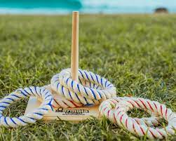
6th | 8th | 10th
Bingo and Hoy  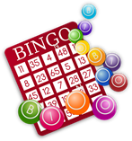 | Family Flip Quiz | Moomba Fun and Games  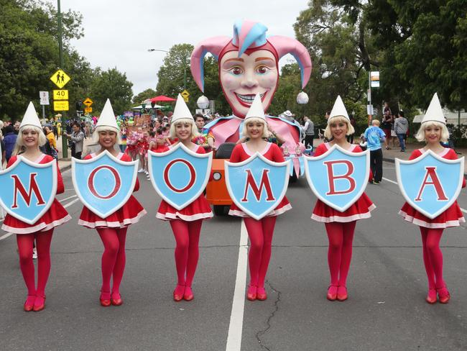
13th  PUBLIC HOLIDAY | 15th  Planes, trains and automobiles Quiz | 17th
20th | 22nd | 24th
Mind Exercises  White Board Words  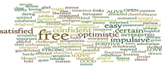 | Qi Gong with Judy | Afternoon Drive
27th  Lunch at Anglesea  Golf Club | 29th  First up best dressed  Who wore what when Quiz | 31st  Table Games
Program subject to change

