December 2022 | Barwon Health Social Support Program  230 Purnell Rd Corio
 | All cancellations to be made by 9:00am on day of attendence: 0447 515 507 or 4215 7049
Monday | Tuesday | Wednesday
5th | 6th | 7th
ALL DAY OUTING  Let’s go for a ride on the Sorrento Ferry $ 28 concession  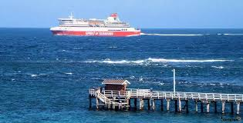  Picnic lunch provided | Rippleside waterfront morning tea. Who would like to dip their toes in the water or just the sand?  Games and puzzles of choice for a relaxing afternoon | Sphinx Hotel Presents  Denise Drysdale  $25  Late lunch back at the Centre
12th | 13th | 14th
Ocean Grove and Surrounds for the day.  Lunch at the Ocean Grove Bowling Club $16 to $18 | Sing-a-long and lunch Christmas show at Clifton Springs Golf Club $25  (sorry cash only) | Morning Melodies  Going Back to the 60’s  Morning tea and show $15  Then lunch at  Norlane Hotel $15
19th | 20th | 21st
Rippleside beach/park for morning tea. Who wants to dip their toes in the water and reminisce?  Afternoon discussion group. What would you like next year’s activities to be? | Mystery drive. Any last minute shopping that you may need from the Op Shop or Cheap As Chips?  Games or  puzzle afternoon | Last day of program for the year. You decide how you want to spend the morning.  Last bingo of the year. Win a special prize
26th  No Program | 27th  No Program | 28th  No Program
Program subject to change

