DECEMBER 2022 |  | Barwon Health Social Support Group McMillan St, Anglesea  Phone: 4215 6721
Anglesea SSP will be closed on Extreme fire rating days. You will be notified ASAP. |  | Program subject to change without notice
MONDAY | WEDNESDAY |  | FRIDAY
2nd
Summertime Quiz

5th  Bingo & Hoy  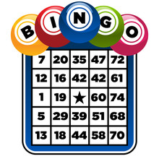 | 7th  Special Morning Tea |  | 9th  Games Arvo  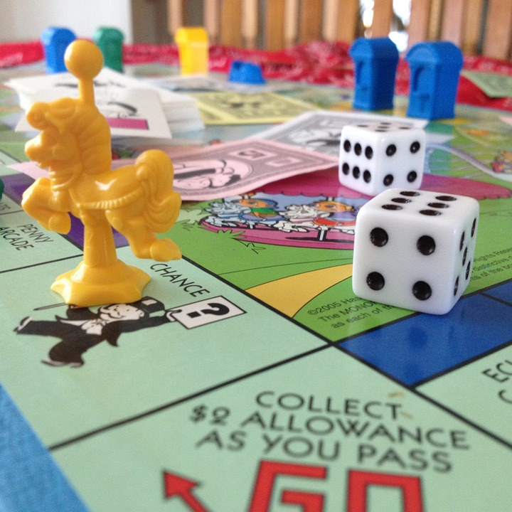
12th  Qi Gong with Judy | 14th  Word Games  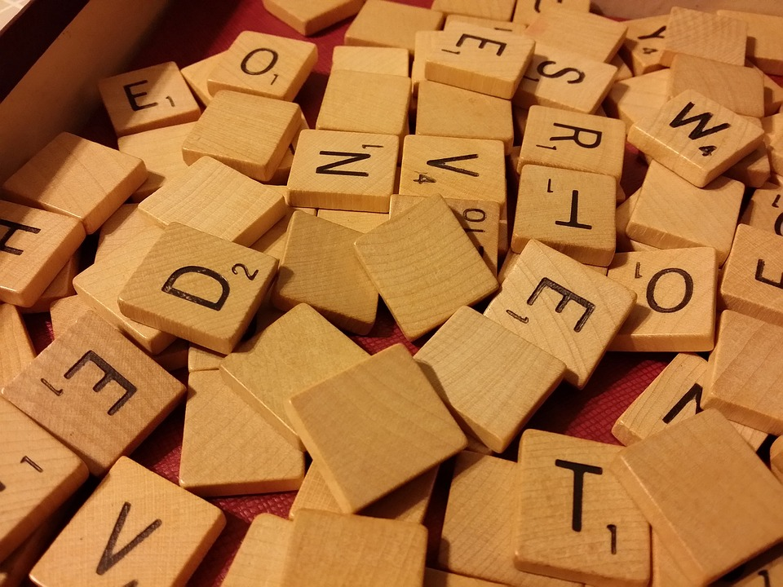 |  | 16th  Xmas Fun & Games
19th  Christmas Celebrations  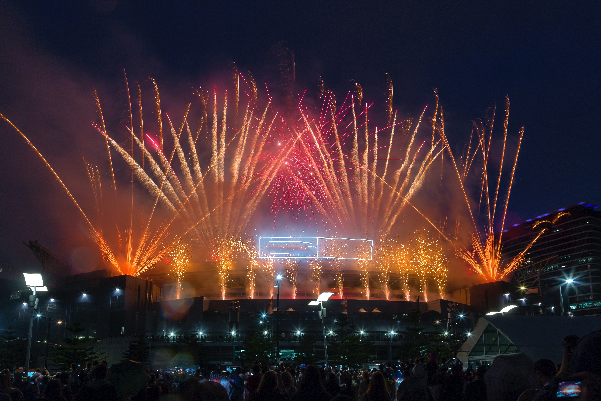 | 21st  Christmas Break Up |  | 23rd  CLOSED
26th  CLOSED | 28th  CLOSED |  | 30th  CLOSED

