Barwon Health Social Support Program
120 Settlement Rd, Belmont Phone 4215 7049
DECEMBER 2022
Mon | Tues | Wed | Thurs | Fri
 |  |  | 1st  MORNING TEA AT THE HUB  AFTERNOON JOYRIDE IN THE GREAT OUTDOORS | 2nd  MORNING TEA AT JACK RABBITT  BBQ LUNCH SUPPLIED
5th BIG DAY OUT  BOX OFFICE CAFÉ ON PAKO  63 DEGREES | 6th XMAS QUIZ  REMINISCING & XMAS CRAFT  TOUR AROUND THE CITY CENTRE VIEW DECORATIONS & XMAS TREE | 7th XMAS CRAFT OR OPP SHOP VISIT  DRIVE TO 13th BEACH | 8th HESSE SOCIAL SUPPORT VISTING US FOR THE DAY XMAS CARD MAKING  VIEW HISTORIAL BUILDINGS DRIVE | 9th MORNING TEA AT ANAKIE SHED  LUNCH AT THE MEREDITH HOTEL
12th BIG DAY OUT  COURT HOUSE CAFÉ’  PIZZAS@RIPPLESIDE | 13th XMAS PARTY AT CLIFTON SPRINGS LUNCH & SHOW BRING $25.00 | 14th XMAS SHOW AT THE SPHINX $15 THEN LUNCH AT THE NORLANE HOTEL YOUR COST | 15th  XMAS PARTY AT CHINESE FOUTUNE GARDEN YOUR COST $$$ | 16th MORNING TEA AT THE RACV CLUB  LUNCH AT OCEAN GROVE BOWLING CLUB
19th BIG DAY OUT  BAYSIDE WALK & CUPPA  YOT CAFÉ’ YACHT CLUB 52 293 705 | 20th GROUP DISSCUSSIONS  BARRABOOL HILLS DRIVE | 21st LAST DAY OF PROGRAM  XMAS DRESSUP | XMAS BREAK NO PROGRAM | XMAS BREAK NO PROGRAM
PLEASE REMEMBER TO NAME ANY ITEMS YOU BRING TO PROGRAM |  | PROGRAM RESTARTS TUESDAY 3rd JANUARY 2023 | MONDAYS & FRIDAYS ARE ALL DAY OUTINGS WITH SOME WALKING INVOLVED | CANCELLATIONS TO BE MADE BY 8.30am OR LEAVE A MESSAGE ON THE 24HR ANSWERING MACHINE

TEAM LEADERS MONTHLY REPORT

Well it’s December the Christmas month, where did this year go to? We here at Belmont have had such an amazing time with you our special clients. We have loved providing you with fun activities & great outings. Thank-you all for attending & supporting our program.

To all my staff it has been a pleasure to be part of such a great team & we look forward to great times ahead next year.

We wish you & your families a very Merry Christmas & a very safe new year.

Our last day of program is Wednesday 21st December & we reopen Tuesday 3rd January.

Just as a reminder I have a 24hour answering machine but this will not be checked until TUESDAY 3rd January programs ‘first day back.

Until next year Ho! Ho! Ho! From Julie Team Leader & Staff Belmont Social Support.

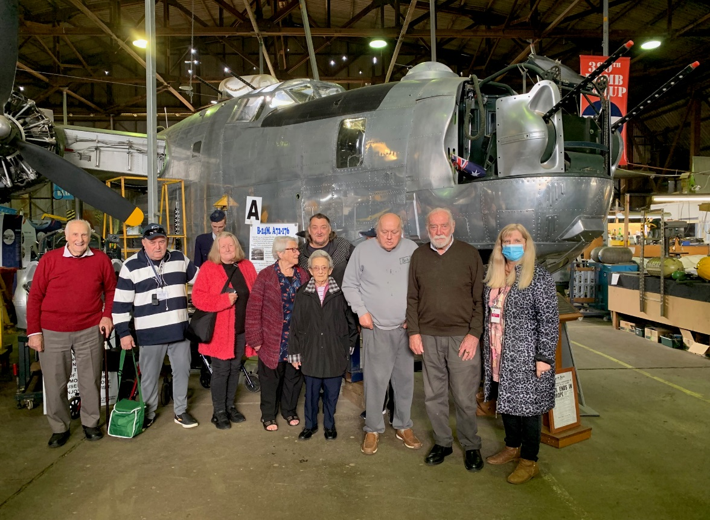
Tuesday Program’s visit to see The B24M Liberator, WWII Bomber at Werribee.

